Sheshnath Gupta
Java MuleSoft/ Microservices Developer with
9.5+ years of experience
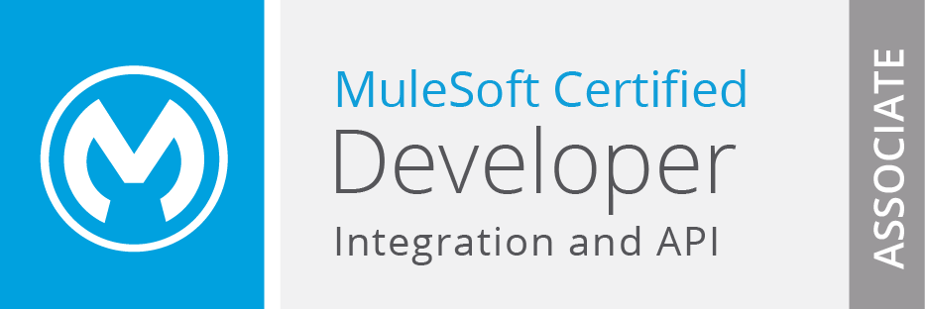
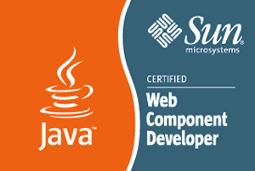
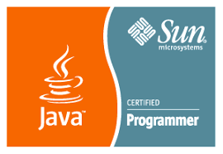

HIGHLIGHTS
- Primary Skills:
- Languages: Mule Soft, RAML, Restful API, Java, Collections, Multithread, Concurrency framework, HashMap, Serialization, Spring IOC, Web Services, SOAP, SOA, REST, PCF, Spring Boot, Microservices
- Tools/ Methodologies: Any point Studio 6.1.x, Eclipse, STS, JBoss-EAP-6.1, Tomcat 7.0, PCF, WPS, WPF, RAD 6.1 WSAD, Bug Tracking Tools, SoapUI, PCF, STS
- Databases: MS SQL Server 2000, MS SQL Server 7.0, Oracle 10g
- Additional Skills:
- Operating Systems: Windows NT 2000/ 4.0, Windows XP/ 95/ 98, Linux, UNIX
- Domains:
- BFS, Retail, Healthcare

SUMMARY
- Experience in software development/ design involving requirement analysis, system design, development, unit testing, integration, documentation and maintenance of software system
- Proficient in MuleSoft, Mule ESB, JMS, RAML, REST API, Java, Collections, Multithread, Concurrency Framework, Serialization, Spring IOC and Web-Services, SOAP, SOA, REST, PCF, Spring Boot, and Microservices
- Software development experience in different varied domains and technologies such as Java, MuleSoft, RESTful API, Spring IOC, and Spring Boot
- Experience in implementing different software methodologies such as Agile, DevOps, Waterfall, and Spiral Models into projects
- Exceptional communication, collaboration, and team building skills with proficiency at grasping new concepts quickly and utilize the same in a productive manner
- Module Lead with good organizational skills to assess needs, set priorities, and meet deadlines

EDUCATIONAL QUALIFICATION
- Master of Computer Applications, UPTU Lucknow (HBTI Kanpur)
- Bachelor of Science (Math), Allahabad University

TRAININGS/ CERTIFICATION
- Sun Certified Programmer for Java 2 Platform 1.4 (SCJP1.4)
- Sun Certified Web Component Developer for Java 2 Platform Enterprise Edition 1.4
- IBM Certified Database Associate DB 2 V8.1
- Building Portlets with IBM WebSphere Portlet Factory 6
- MuleSoft Certified Developer - Integration and API Associate

PROJECT EXPERIENCE
Synechron Technologies Pvt. Ltd., Pune Jul’16 till date
Project: AMG Skylight AIP (HSBC) Duration : July 2016 - till date
Client: HSBC
Role: Module Lead
Description: The narrow objective of skylight is to replace CRD with Bloomberg Asset and Investment Manager (AIM). However, the broad objective of Skylight to develop and implement a front office Global Target Operating Model (GTOM). The GTOM will standardize the people processes technology and data used by the GTOM will standardize the people processes technology and data used by AMG front office.
We process the instrument, issuer, pricing, rating, and classification data to HSBC Global Asset Management (Deutschland) eData as part of overall skylight program implementation.
Responsibilities:
- Worked from beginning of project and delivered each phase successfully
- Worked on AIM Producer Adapter and IDS Consumer Adapter to process transaction, cash, and holding file for FIS and calculation purpose from one point (AIM) to other point (EServer)
- Worked on IPAS Producer Adapter and eData Consumer Adapter to instrument, issuer, pricing, rating, and classification data to HSBC Global Asset Management (Deutschland) eData as part of overall skylight program implementation
- Worked on CADIS Producer Adapter and TRAC Consumer Adapter to process FX Rate of each businesses day to TRAC for analysis and calculation purpose for specific currency type/ spot
- Created multiple sftp Adapter such as idssftpAdapter, eDataSFTPAdapter, bplSftpAdapter, and AimUSSftpAdapter, which are used to pull and push files to respective socks proxy location
- Worked on multiple consumer, producer, and sftp adapter for pull/ push file on socks proxy system
- Delivered the components for IPAS-->TRAC, TRAC-->IPAS, CAM--> RDS, FileStreamingAPI, duplicate File Processing feature, EmailNotiferService for AIMHK, AIMFR, and AIMDE
- Created tagged release to move package from one environment to other after signoff from QA and UAT team
- Created release document for tagged release
- Automated the deployments process for all producer and consumer

Environment: DEV, SIT, UAT, PROD

Capgemini Dec’13 to Jul’16
Project: Multi Spine Engine Duration : Dec 2013 - July 2016
Client: State Streets
Role: Individual Contributor (IC)
Description: Spine engine requires a flexible and robust “Engine” that will support the variety of “Spines” arising from variety of clients and their business process and logic. Is should be able to:
- Accept and interpret the assembled steps for each Spine
- Execute steps in either a single thread or parallel mode as requested by the spine definition
- Execute a “spine” (sub-spine) in a step if requested by the step definition
- Retrieve necessary data for processing and provide calculated results as requested by the spine definition
- Evaluate parameters and associated data as requested by the spine definition
- Validate the spine and report problems such as incompatible data flow, and data levels
- Handle exceptions and error conditions during run time
Responsibilities:
- Worked from beginning of project and deliver each phase successfully
- Implemented latest Java API, SOAP, REST, and Concurrency Framework
- Implemented auto deployed of JBPM process on JBPM container
- Created JBPMN custom component (SOAP, REST, Excel, Flat File, and User Review)
- Worked on $deployment and written UNIX script file for this

Environment: DEV, SIT, UAT, PROD

Cognizant Mar’11 to Dec’13
Project: BK Payment Change and Advances Made Notifications Duration : Jan 2013 - Dec 2013
Client: Nation Star
Role: Individual Contributor (IC)
Description: Create a bidirectional feed with 4S Technologies (vendor) that provides bankruptcy payment change, advances made fee notices, and transfer of claim data to fulfill our obligation to timely notify the bankruptcy courts of these types of Notifications.
Responsibilities:
- Developed batch programs for Order File and Return File (Acknowledgement File and Return File) which fetch data from the LSAMS table based on a defined criterion, downloaded the corresponding images from FileNet, and created a xml file and vice versa
- Sent e-mail notification to recipients for successfully submission of order (PCN, PPFN, TOC) file, Acknowledgement file and Return file
- Created a flat file of Acknowledgement File and Return File for LSAM table update
- Created flowchart, sequence diagram, deployment instructions, document for properties file, and test case document for order file, and acknowledgement file/ return file

Environment: DEV, SIT, UAT, PROD

Project: Check Processing Phase 2/ 3 (Project 7404) Duration: Jan 2012 - Dec 2012
Client: Nation Star
Role: Project Associate
Description: Although the functionality for this system has been added to the Checks Workflow Automation application, searches and work item history will not be available. Based on the data payments will be routed to the Review, Foreclosure, and Reject/ Acquisition queues for each payment source.
Decisions to accept or reject the payment will be manually made by the processors based on the data presented to them.
Responsibilities:
- Developed UI pages for check processing (Review, Foreclosure, Reject, and Acquisition Queues)
- Worked on DAO, web services implementation task
- Engaged in unit testing and preparing test case document

Environment: DEV, SIT, UAT, PROD

Project: Check Processing (Checks Workflow Automation) Duration : Mar 2011 - Dec 2011
Client: Nation Star
Role: Individual Contributor (IC)
Description: Nationstar receives approximately 10, 000 checks at VR2 each month, based on 600, 000 loans serviced. We want to scan these checks in the mailroom, extract data using character recognition software and use that data to automatically create a posting advice file. Any items that need further information for posting will be routed to a representative within Account Services or to a specific business unit that is handling the loan. Once these manually reviewed items are routed to the posting advice file we will automatically post to LSAMS using the existing SMART file and payment posting logic. Once posted, settlement files will be sent electronically to Wells Fargo for settlement.
Responsibilities:
- Developed UI pages for check processing such as dashboard, queue, step processor, check search, completed check search, work in progress, and payment reconciliation
- Engaged in unit testing and preparing test case document

Environment: DEV, SIT, UAT, PROD

IBM Mar’07 to Jun’09
Project: AHOLD Duration: Mar 2007 - Jun 2009
Client: Albert Heijn B.V
Role: Individual Contributor (IC)
Description: Albert Heijn B.V. is a super market chain founded in 1887 in Oostzaan, the Netherlands. It is named after Albert Heijn Sr. founder of the first store in Oostzaan. The AHOLD Plaza Portal solution plays a key role in meeting the business needs providing an integrated system. The Plaza Portal is a WebSphere Portal 6 solution together with Workplace Web Content Management tool, which eases the maintainability. Further modification to the system using tools such as WebSphere Portlet Factory reduces the complexity. The system is designed to aid the store managers to assign, manage, and delegate work from within and outside the store. This system is being designed to connect 800 stores with a total number of 10, 000 users using it.
Responsibilities:
- Developed MijnLeveringenAdmin, ReferenceList Admin, and DC Meldingen and fixed bugs related to build/ theme/ skins of these portlets
- Engaged in Micro design of MijnLeveringenAdmin, ReferenceList Admin, and DC Meldingenportlets
- Developed AppLaunchAdminportlets and 5 sub portlet and fixed bugs related to build/ theme/ skins of these five portlets
- Engaged in Micro design of AppLaunchAdmin Admin portlets

Environment: DEV, SIT, UAT, PROD

